**Functional Requirement Document**

**for Finding Hospitals Site**

**Submitted to**

**Cognizant Technology Solutions**

**Submitted by**

Srikanth Burra (899493)

SreejaReddy Nomula (899461)

Vuppalapati Niharika (899411)

Rashmitha Reddy (899441)

Sonia Banu Shaik Mohammed (899410)

**For more information please visit on website:**

[**https://www.practo.com**](https://www.practo.com)

**Date of Submission**

April 2021.

**FUNCTIONAL SPECIFICATIONS DOCUMENTATION**

**TEAM HACKTHON EXPRESS**

**April 2021s**

**Version 1.0.0**

| VERSION HISTORY | | | | |
| --- | --- | --- | --- | --- |
| VERSION | APPROVED BY | REVISION DATE | DESCRIPTION OF CHANGE | AUTHOR |
|  |  |  |  |  |
|  |  |  |  |  |
|  |  |  |  |  |
|  |  |  |  |  |
|  |  |  |  |  |
|  |  |  |  |  |
|  |  |  |  |  |

**Functional Specifications Document**

**Authorization Memorandum**

I have carefully assessed the Functional Specifications Document for the

<FINDING HOSPITALS >.

MANAGEMENT CERTIFICATION - Please check the appropriate statement.

______ the document is accepted.

______ the document is accepted pending the changes noted.

______ the document is not accepted.

We fully accept the changes as needed improvements and authorize initiation

of work to proceed. Based on our authority and judgment, the continued

operation of this system is authorized.

Kannan, Kathikeyan

NAME DATE

Project Manager _______________________

_______________________________ _____________________

NAME DATE

Director

*Add other names and roles as necessary.*

TABLE OF CONTENTS

1.0 INTRODUCTION 4

1.1 Purpose 4

1.2 Abbreviations and Acronyms 4

1.3 Refrences 4

1.4 Document conventions 4

2.0 GENERAL DESCRIPTION 5

2.1 Product Context 5

2.2 User Classes and Characteristics 5

2.3 Overview of Functional Requirements 6

2.4 Overview of Data Requirements 6

2.5 Operating Environment 7

2.6 General Constraints, Assumptions, Dependencies, Guidelines 7

2.7 Design and Implementation Constraints 7

2.8 User Documentation 7

3.0 REQUIREMENTS 8

3.1 External Interface Requirements 8

3.1.1 User Interfaces 8

3.1.2 Hardware Interfaces 8

3.1.3 Software Interfaces 8

3.1.4 Communications Interfaces 9

3.2 Functional Requirements 9

3.2.1 Template for functional requirements 9

3.3 Performance Requirements 15

3.4 Security 15

3.5 Usability 15

3.6 Other Requirements 15

Appendix A. Analysis Models 17

Appendix B. Issues List 21

**1.0. INTRODUCTION**

## 1.1. Purpose

FINDING HOSPITALS [Practo] is the trusted website and they will help us to find hospitals at familiar home town. It connects them with everything they need to take good care of themselves and their family assessing health issues, finding right doctor, booking diagnostic tests, obtaining medicines, storing health record.

**1.2. Abbreviations and Acronyms**

* HTML- Hyper Text Markup Language
* CSS -Cascading Style Sheets
* RAM - Random Access Memory.
* GB - Giga Bytes.
* HTTP –Hyper Text Transfer Protocol

**1.3. References**

<https://www.guru99.com/functional-requirement->

specification- example.html

**1.4. Document conventions**

Bold faced text has been used to emphasise headings and

subheadings. Arial font has been used with headings of size 16

and subheadings of size 14 and the description with12.

# 2.0. GENERAL DESCRIPTION

## 2.1. Product Context

PRACTO website’s main function is to find the hospitals at familiar home town. It connects them with everything they need to take good care of themselves and their family assessing health issues, finding right doctor, booking diagnostic tests, obtaining medicines, storing health record

## 2.2. User Classes and Characteristics

These are the users who will be interested in FINDIING HOSPITALS website.

|  |  |  |  |
| --- | --- | --- | --- |
| **S.NO** | **NAME OF USERS** | **ROLE** | **CHARCTERSTICS** |
| 1 | Super Users | Authorized **Finding Hospitals** staff that is responsible for administering, supporting and maintaining the Finding Hospital (Practo) website. | Uses the website to configure and troubleshoot the behavior of website. |
| 2 | Administrators | Authorized staff who are responsible for reporting on and administering the data present in Finding Hospital website. | Uses the website to perform day-to-day reporting and administrative work to maintain the running state of website. |
| 3 | System Users | Users with or without their accounts can use this website. Users can have accounts attached with Google | Uses website to check Hospitals and help to find doctors |

## 2.3. Overview of Functional Requirements

1. Search city name
2. Choose Hospital
3. Select Open 24X7 check Box
4. Select accredited check Box
5. Select Filters check Box
6. Select Parking check Box
7. List Hospital names
8. Click on diagnostic page
9. List Top cities
10. Click on ‘For providers’
11. Click on ‘Corporate Wellness’
12. Fill invalid data
13. Capture warning Message

**2.4. Overview of Data Requirements**

* **Input value**: input data should be from different sources.
* **Static value**: a static application or system is required for automation.
* **Output**: expected output data is preferred.

**2.5. Operating Environment**

* **Processor**: Intel core
* **RAM:** 4 GB
* **OS**: windows 10

## 2.6. General Constraints, Assumptions, Dependencies, m

## Guidelines

Each user has to enter accurate information. No user can share their credentials.

## 2.7. Design and Implementation Constraints

* The application has used POM, Maven, TestNG, Jenkins, HTML as main technologies.
* HTTP protocols are used to access the web application.
* Since Find Hospital is a web based application, internet connection must be established.
* This web application runs on different browsers.

## 2.8. User Documentation

There are no user manuals, online helps as it is easily understood.

# 3.0. REQUIREMENTS

## 3.1. External Interface Requirements

### 3.1.1. User Interfaces

* All users will see the same page when they enter in this web site.
* When a user tries to search for hospital , we have to enter a city name and then choose Hospital
* When a user tries to take appointment, go to Corporate wellness fill accurate information
* After being authenticated by correct details, user will be directed to their corresponding suggestions.
* The user interface is simple and easy to understand the terminology.

### 3.1.2. Hardware Interfaces

* No extra hardware interfaces are needed.
* The system will use standard hardware and data communication resources.

### 3.1.3. Software Interfaces

* **Os**: windows 10
* **Web browser**: The system is a web based application; clients need any web browser such as chrome, Firefox, opera, internet explorer. The computer must have an internet connection in order to access with the system.

### 3.1.4. Communications Interfaces

* This system uses communication resources which includes HTTP protocol for communication with web browser.

## 3.2. Functional Requirements

## 3.2.1. Template for functional requirements

**a. Search city name.**

1. **Input:** enter city name
2. **Output:** city name selected

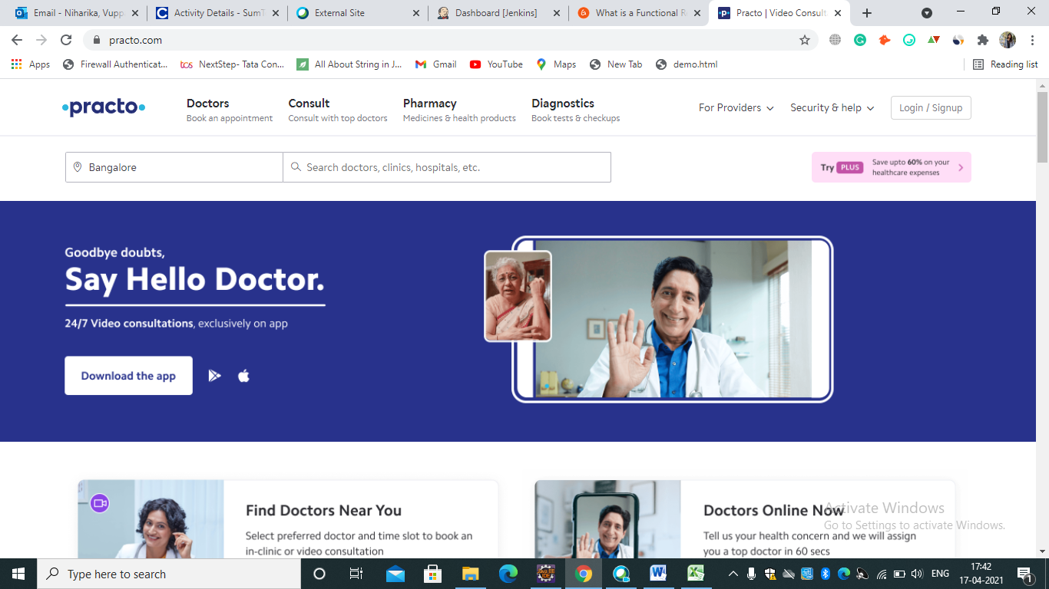

**b. Choose Hospital**

1. **Input:** Choose Hospital
2. **Output:** Displayed Hospital

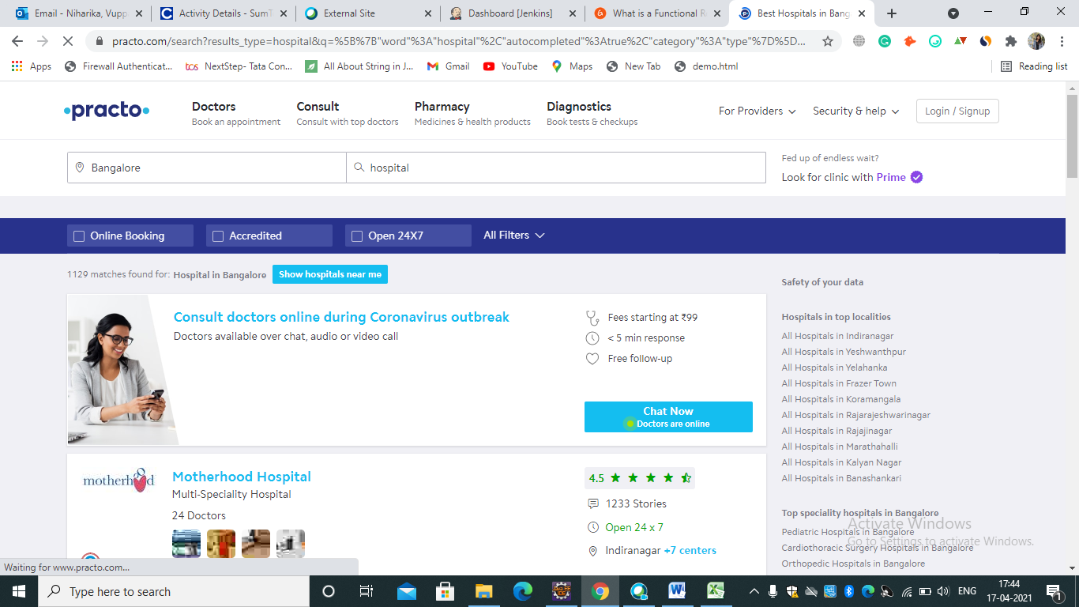

**c. Select accredited Check Box**

1. **Input:** Select accredited Box
2. **Output:** accredited check box selected

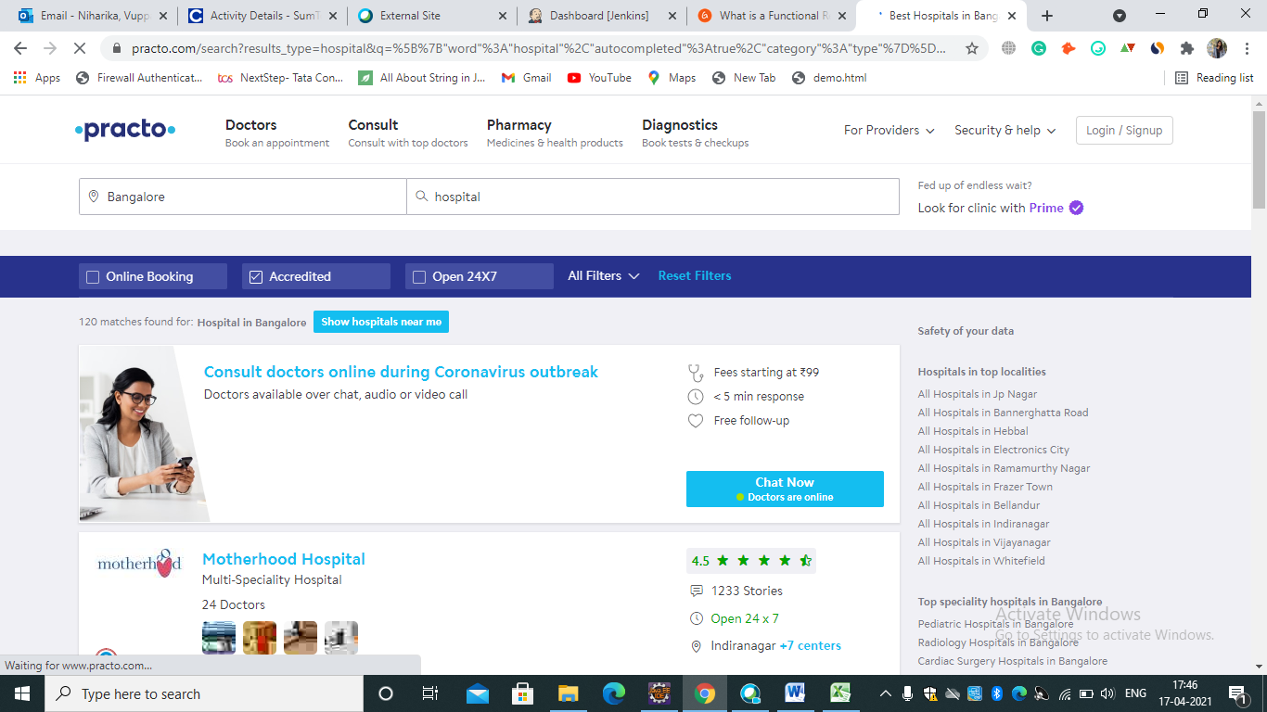

**d. Select ‘Open 24X7’ Check Box**

1. **Input:** Select 24X7 Check Box
2. **Output:**  24X7 Check Box selected

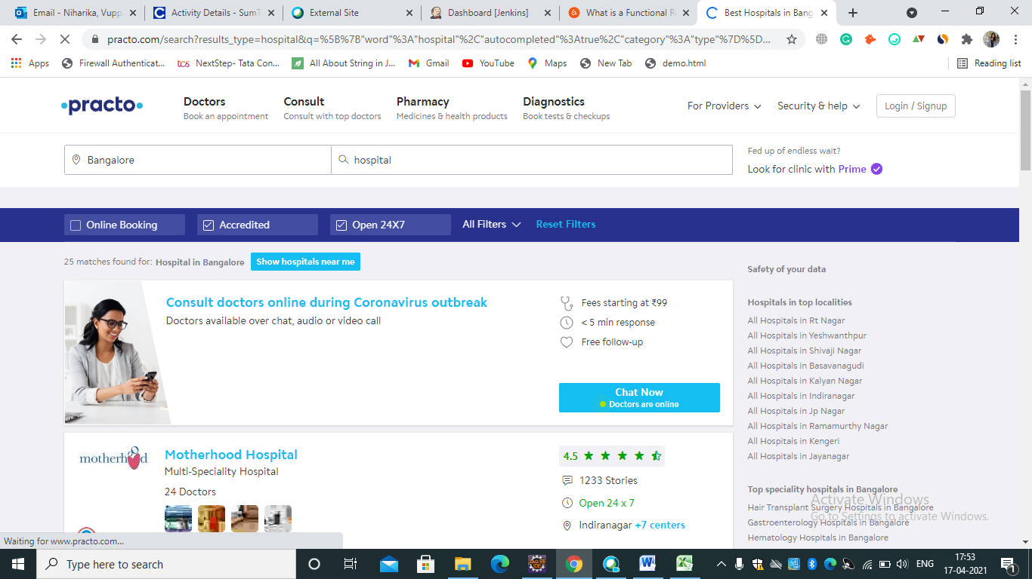

**e. Select Filters**

1. **Input:** select Filters
2. **Output:** Filters selected

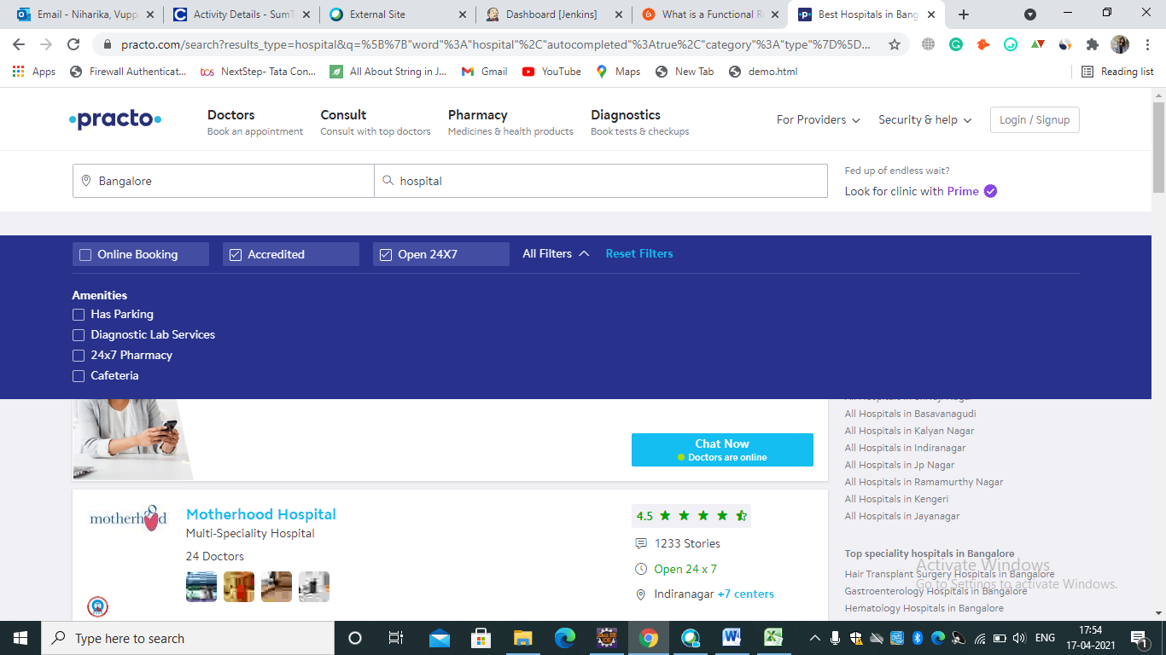

**f. Select ‘Has Parking’**

1. **Input:** Select ‘Has Parking’
2. **Output:** ‘Has Parking’ Selected.

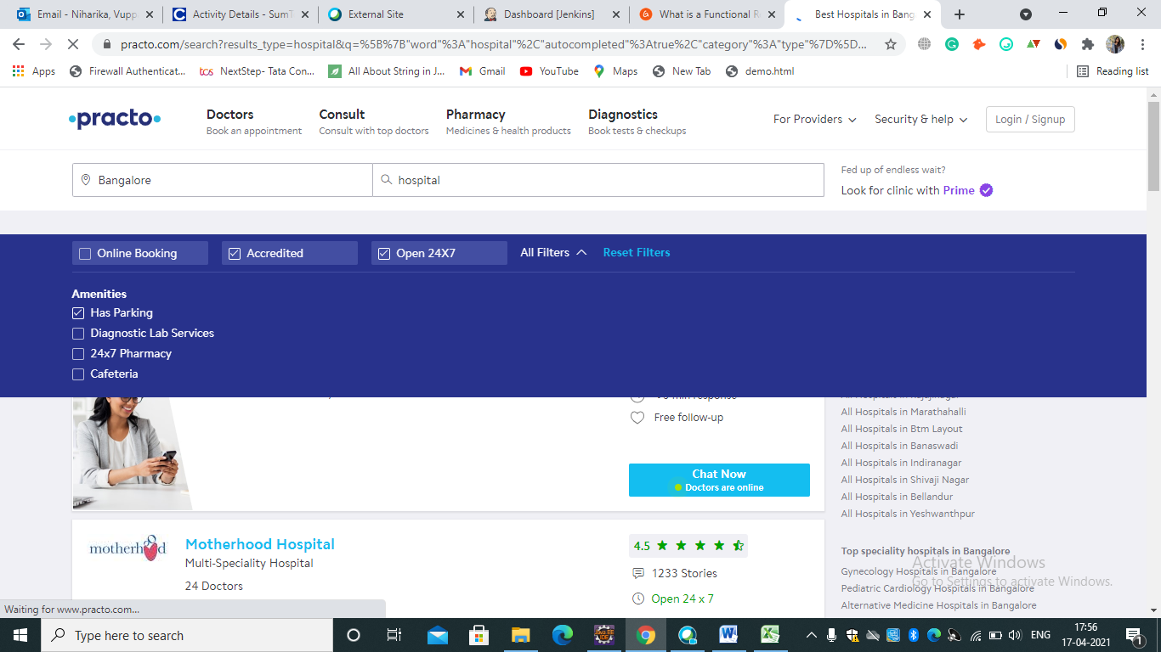

**g. List Hospitals**

1. **Output:** List Hospital name

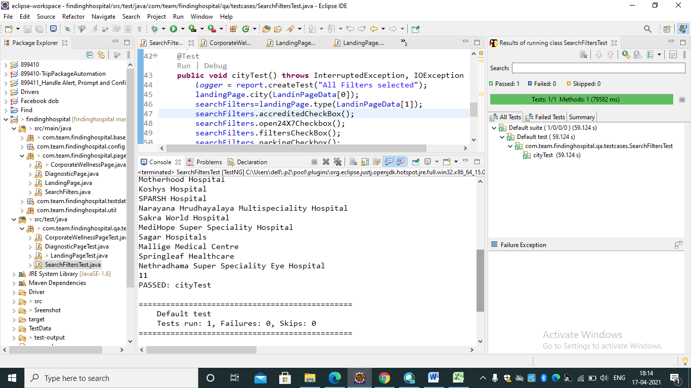

**h. Click on diagnostics**

1. **Input:** Click on diagnostics
2. **Output:** diagnostics button clicked

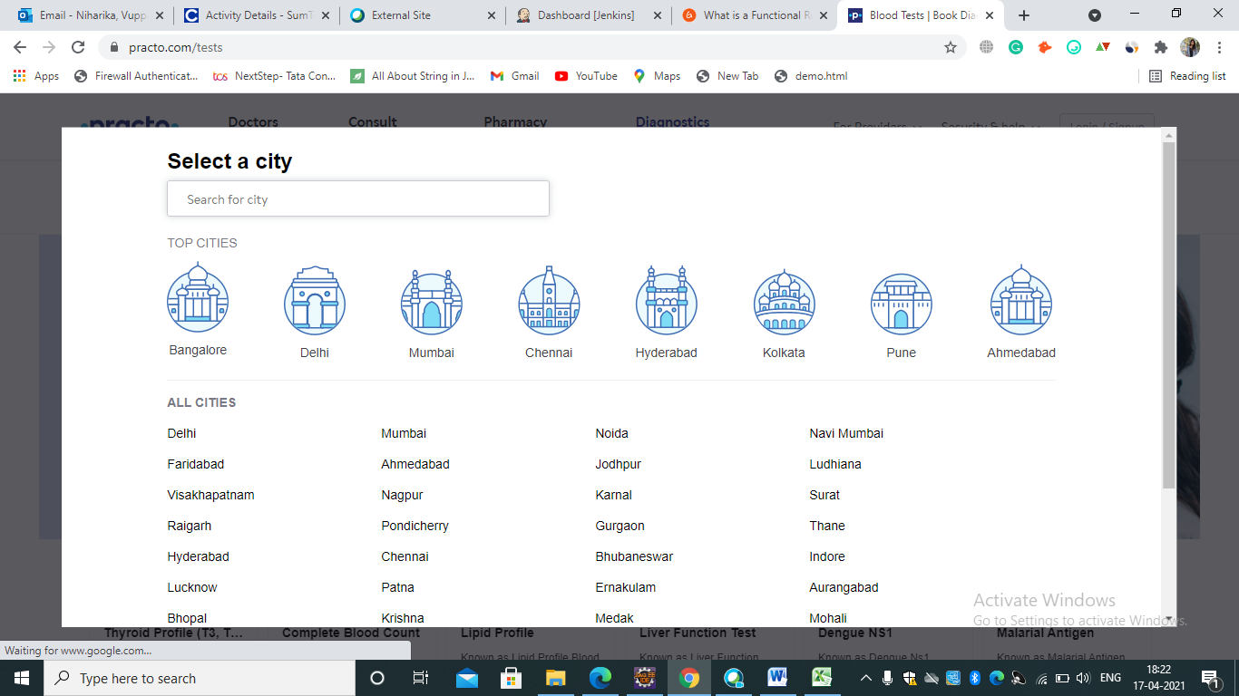

**i. List Top cities**

1. **Output:** List Top cities

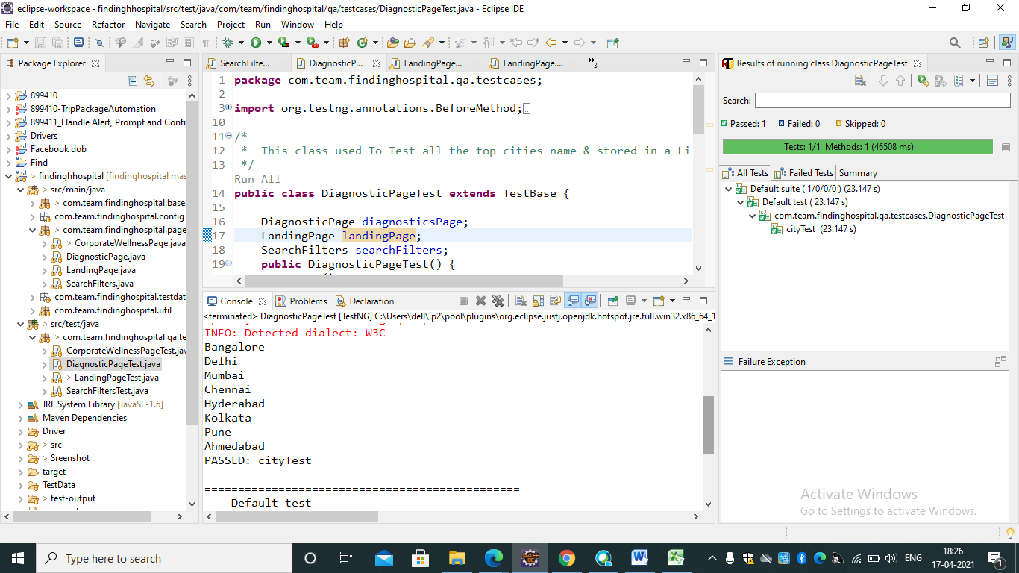

**j. Click on ‘For providers’**

1. **Input:** Click on ‘For providers’
2. **Output:** ‘For providers’ clicked.

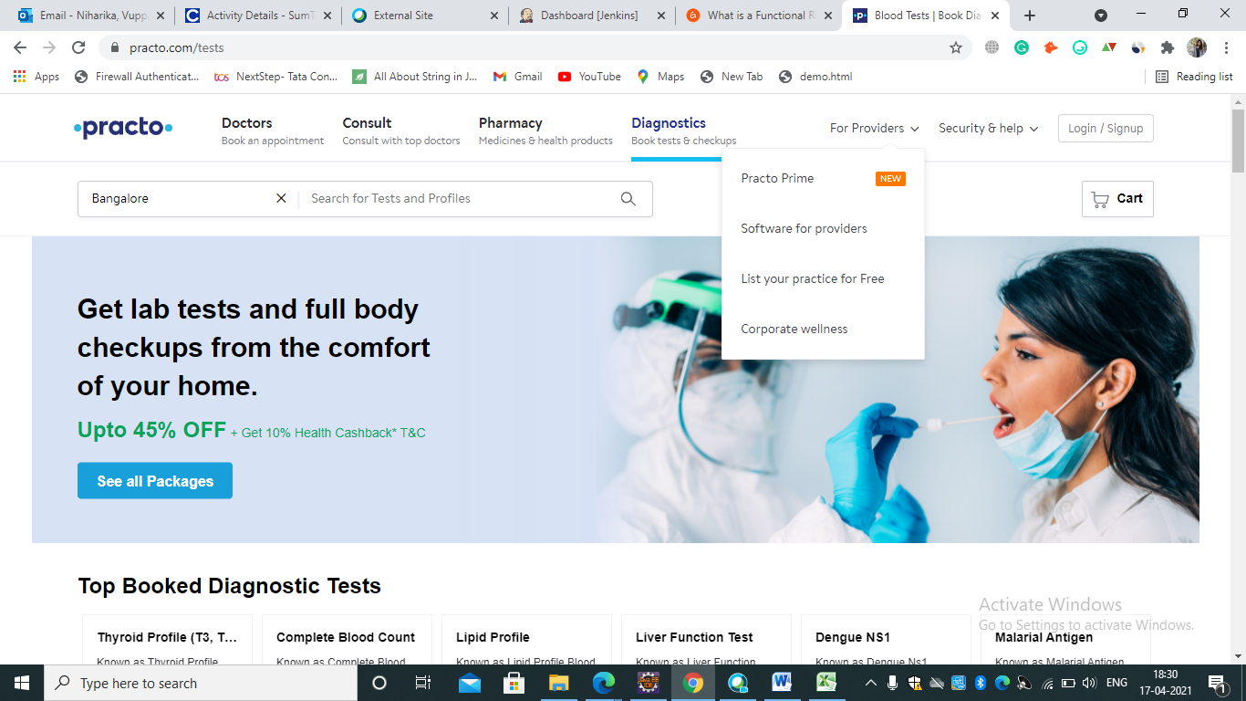

**k. Click on ‘Corporate wellness ’**

1. **Input:** Click on ‘corporate wellness’

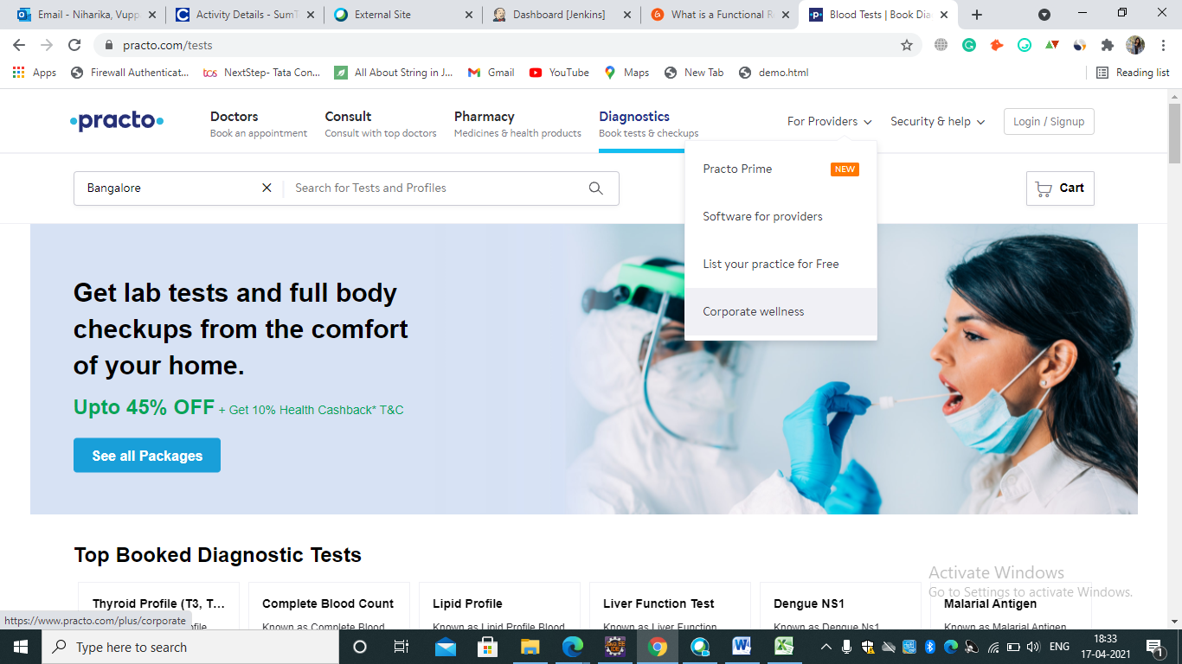

1. **Output:** ‘corporate wellness’ clicked.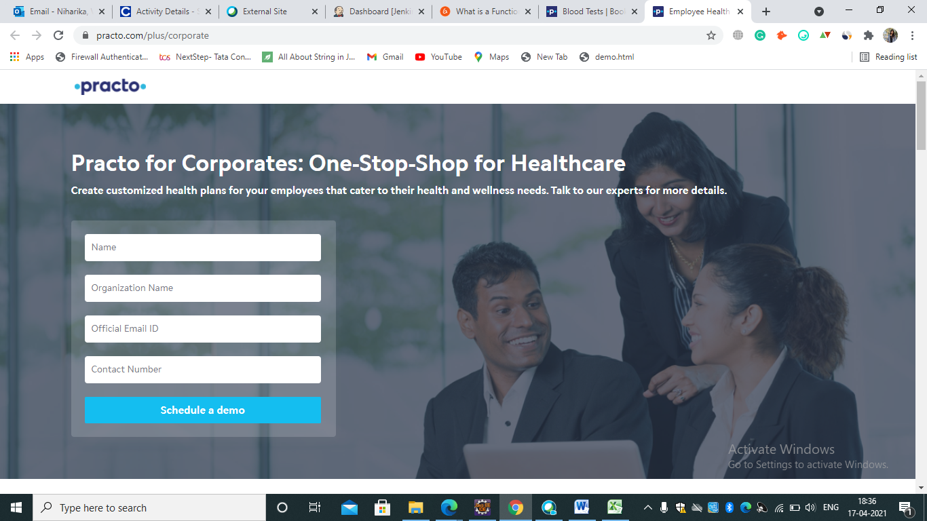

**m. Enter the Invalid details**

1. **Input:** Enter the invalid email in details
2. **Output:** Error message is displayed

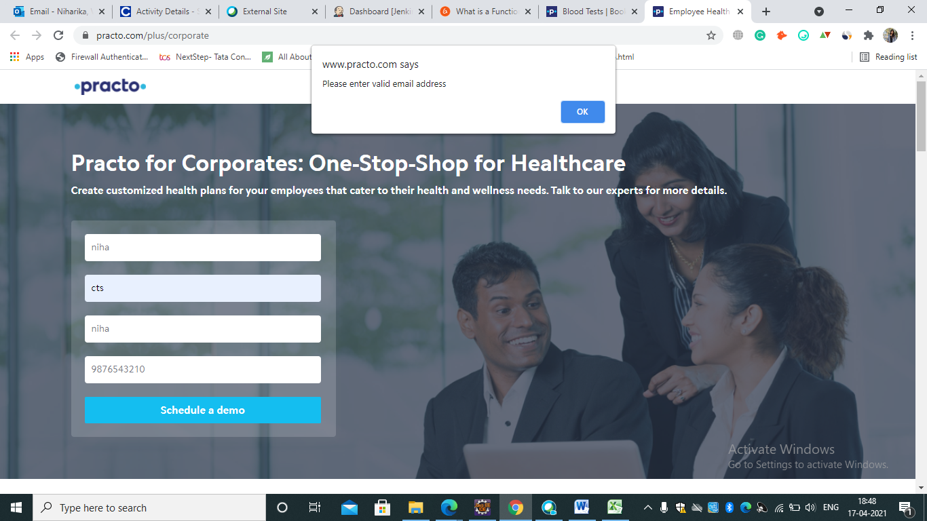

## 3.3. Performance Requirements

The system response time for every interaction conducted by the user should not exceed more than a minimum of 10 seconds. The system should provide a high performance rate when executing users input and should be able to provide response within a short time span usually 50 seconds for a complicated task and 20- 25 seconds for less complicated task.

## 3.4. Security

The system provides authorized access; hence we can only login with valid credentials.

## 3.5. Usability

The system provides several options which are very easy to use. Terminology is easy so, we can interact with the application very easily.

## 3.6. Other Requirements

**a. Availability:**

The system should be available for access at 24 hours, 7 days a week .Also in the occurrence of any major system malfunctioning, the system should be available in 1 to 2 working days, so that business process is not severely affected.

**b. Error handling:**

Error should be considerably minimized and an appropriate error message that guides the user to recover from the error should be provided. Validation of user’s message is highly essential.

**Appendix A. Analysis Models**

List any attached / referenced documentation such as data flow diagrams, class diagrams, state-transition diagrams, entity-relationship diagrams, etc.

|  |  |  |
| --- | --- | --- |
| **ANALYSIS MODELS** | | |
| **DOCUMENT NAME** | **DESCRIPTION** | **LOCATION** |
| FUNCTIONAL REQUIREMENT DOCUMENT | FINDING HOSPITAL | <https://www.practo.com> |
| DIAGNOSTIC PAGE |
|
| CORPORATE WELLENESS |
|

**DATA FLOW DIAGRAM**

**1. Data Flow for Hospital-Search**

Launch the website

Select “Bangalore” from “Search Location” List Box

Enter Hospital in Search Box

Select “Open 24*7” check box  
and select accredited check box

Select “Has Parking” from “All Filters” Drop Down menu.

**2. Data Flow for Diagnostics-Top Cities**

Launch the website

Click the Diagnostics Tab

Click the Back Button

**3. Data Flow for Corporate Wellness**

Launch the website

Select Corporate wellness

Name

Enter the Invalid Details

Organization Name

Official Email ID

Contact Number

Alert message should be displayed

Schedule a Demo

**Appendix B. Issues List**

|  |  |  |
| --- | --- | --- |
| **ISSUES LIST** | | |
| **ISSUE ID** | **ISSUE DESCRIPTION** | **STATUS** |
| IS_1 | **ISSUE :** Sometimes not able to select Hospital in check Box.  **Solution** : Saved entire data in Array List and we compared each and every word with ‘Hospital’ | COMPLETED |

**DISCLAIMER**

Any articles, templates, or information provided by Smart sheet on the website are for reference only. While we strive to keep the information up to date and correct, we make no representations or warranties of any kind, express or implied, about the completeness, accuracy, reliability, suitability, or availability with respect to the website or the information, articles, templates, or related graphics contained on the website. Any reliance you place on such information is therefore strictly at your own risk.